[url=http://knittingtofit.com/][/url]
| HOME | SITE DIRECTORY | CONTACT US | ORDER |

KNITTING  MACHINES |  | KNITTING  MACHINES
Representing the PASSAP line of Knitting Machines and Accessories in Canada & around the world

DIAGRAMS & NUMBERS - E-6000

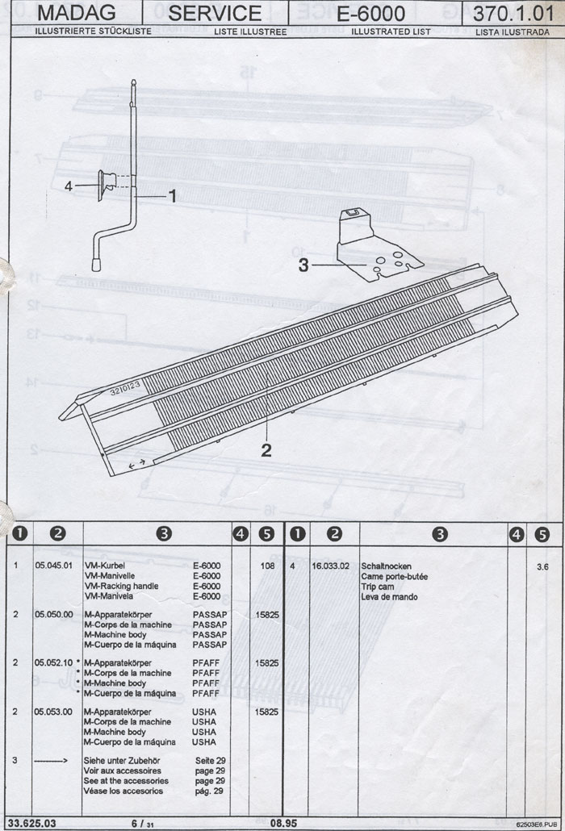

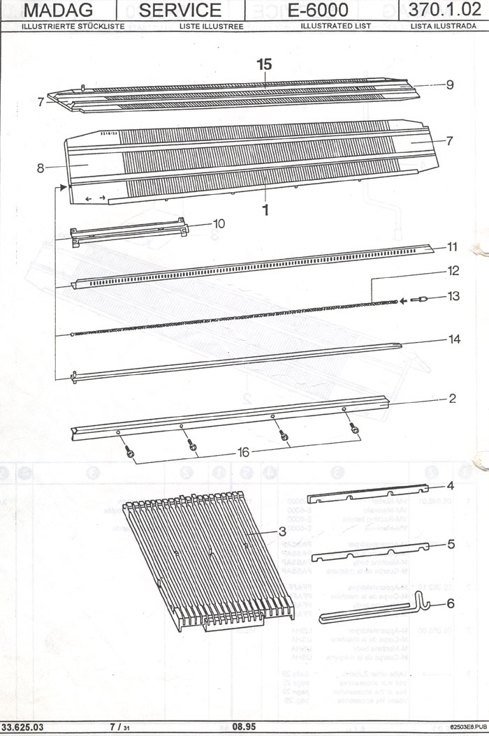

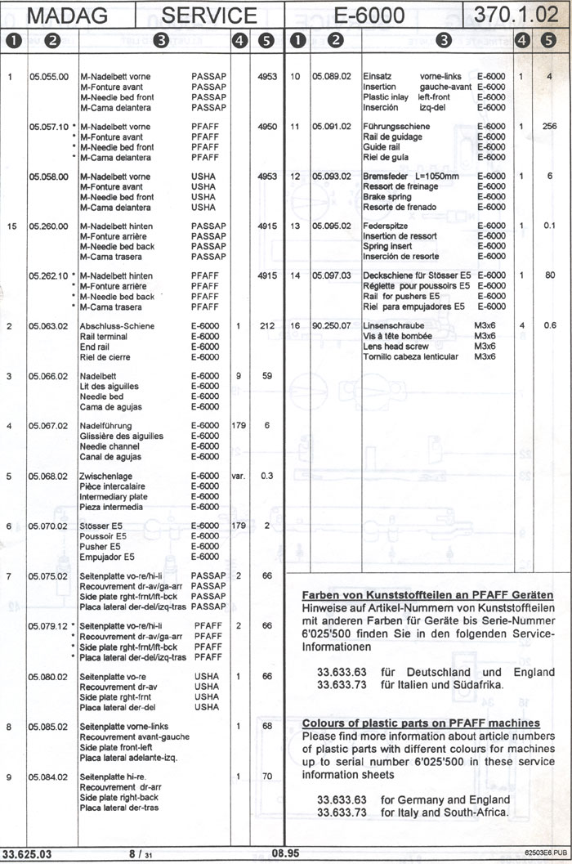

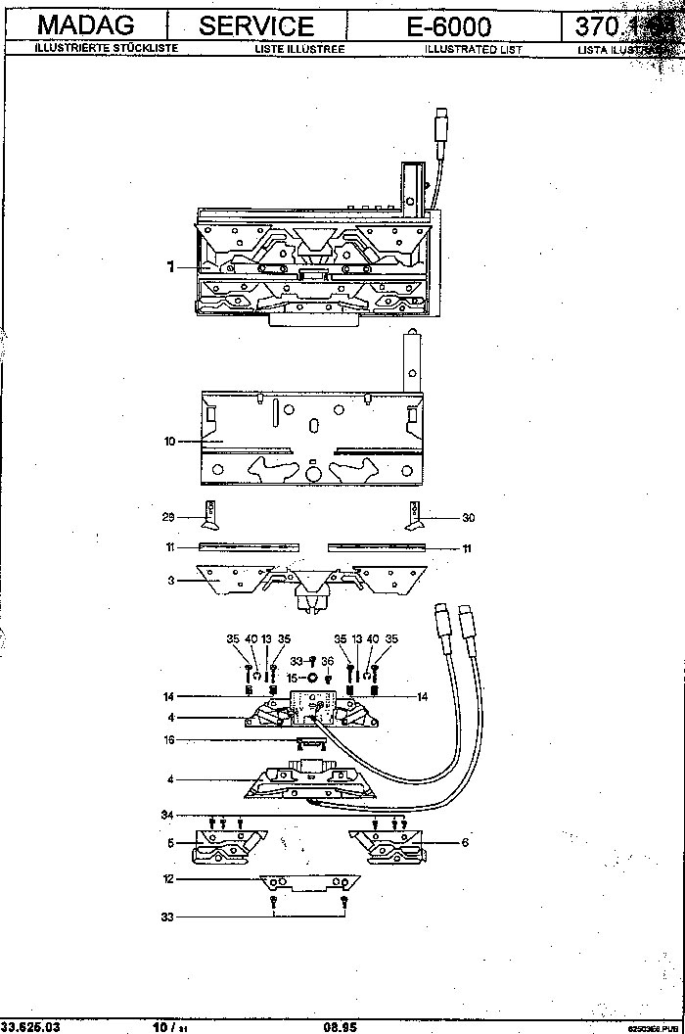
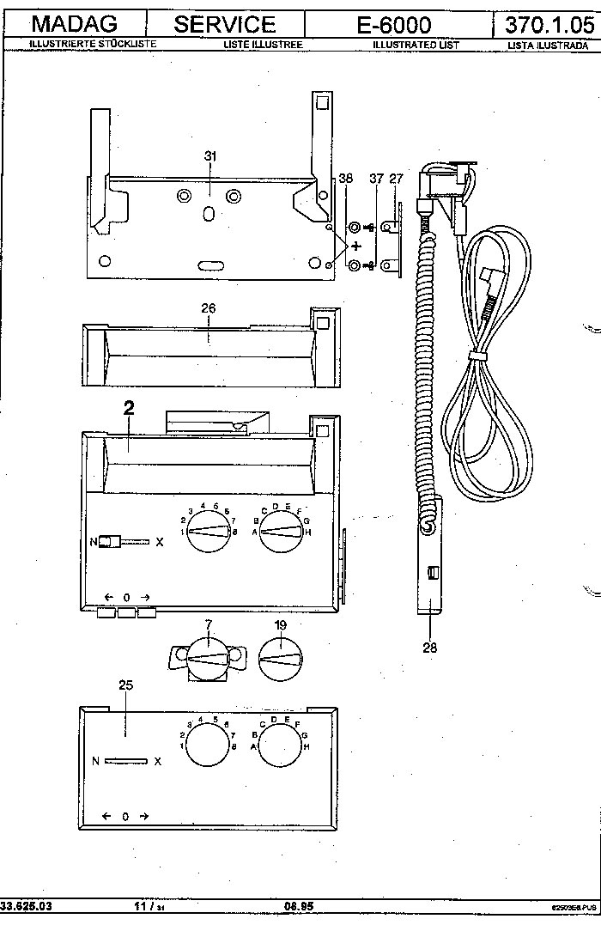
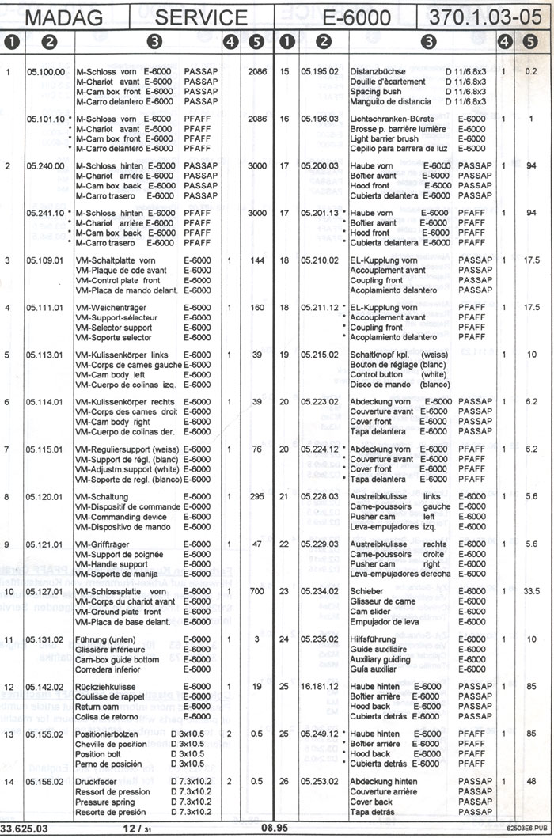
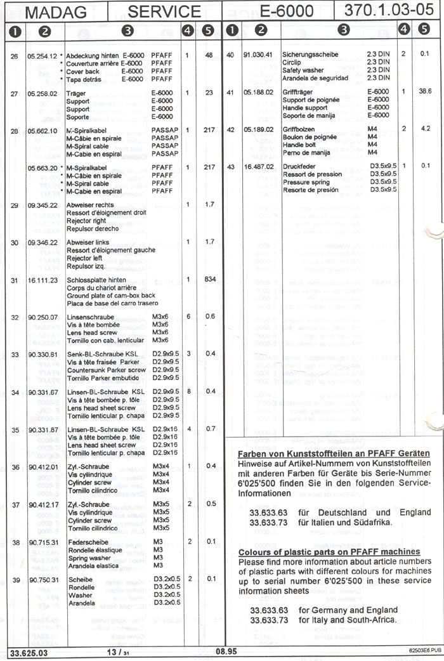
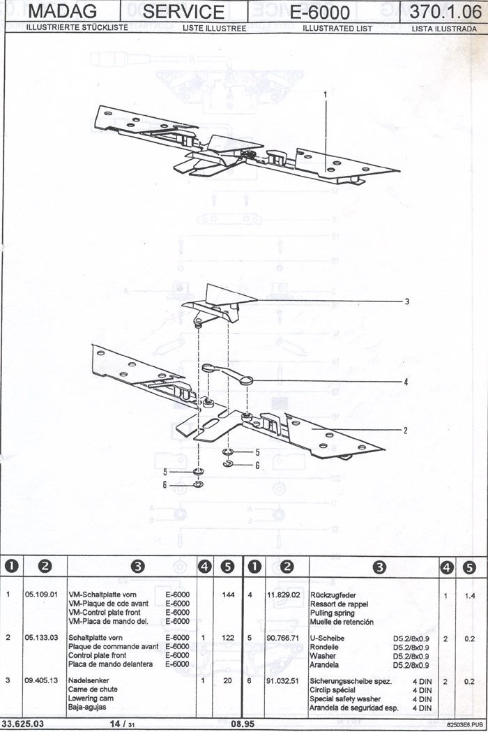
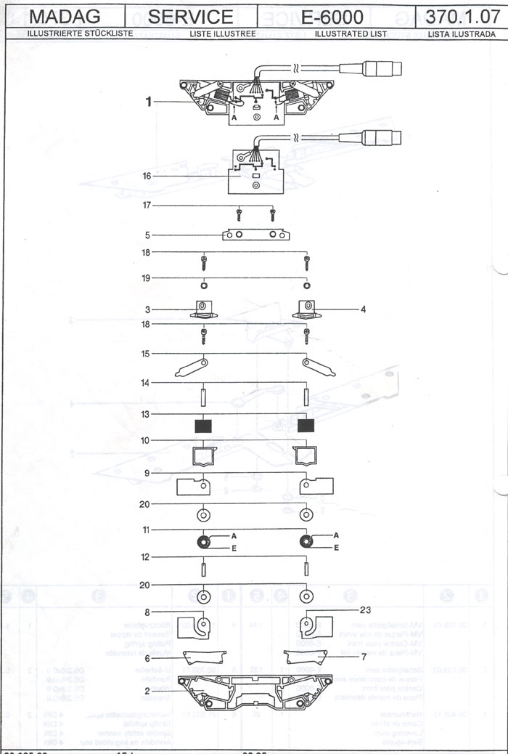
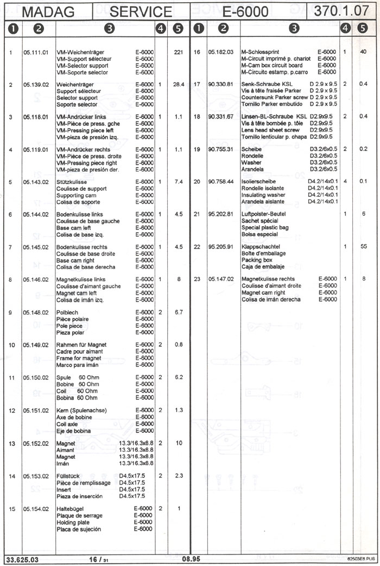
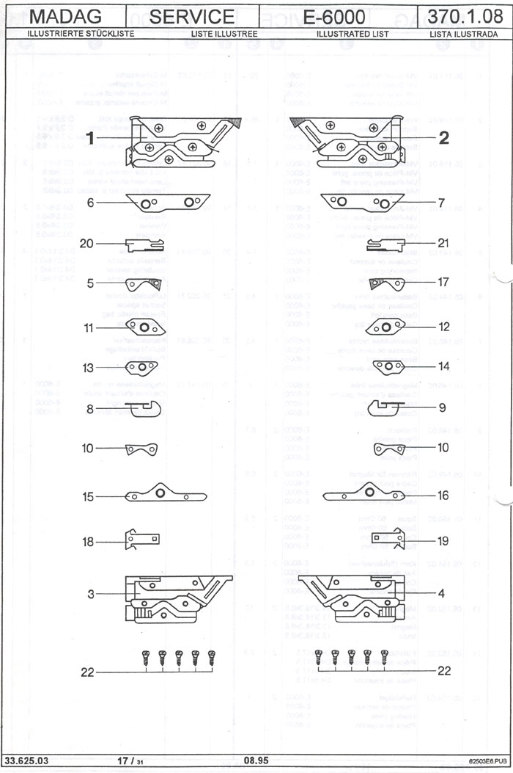
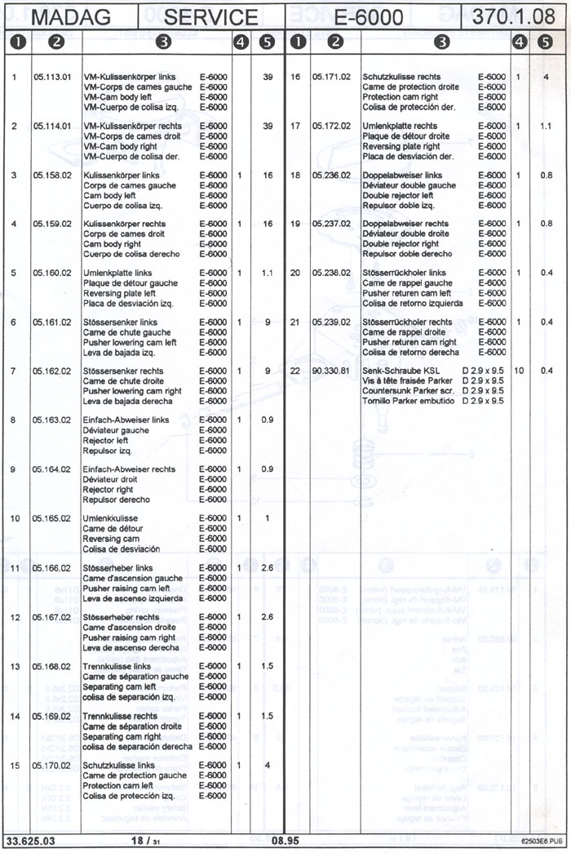
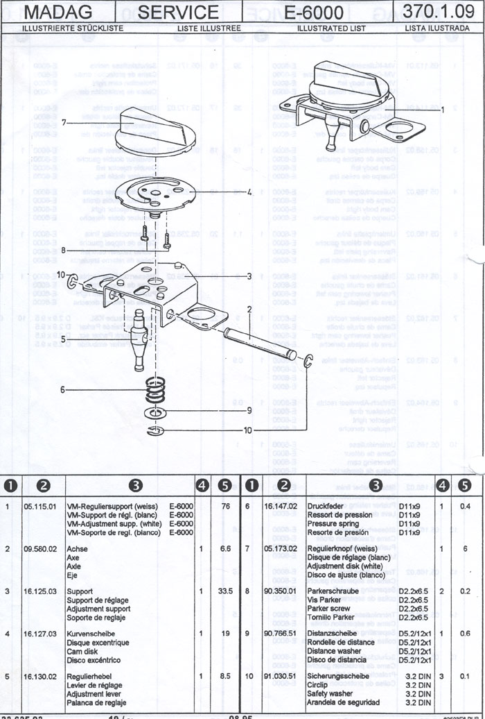
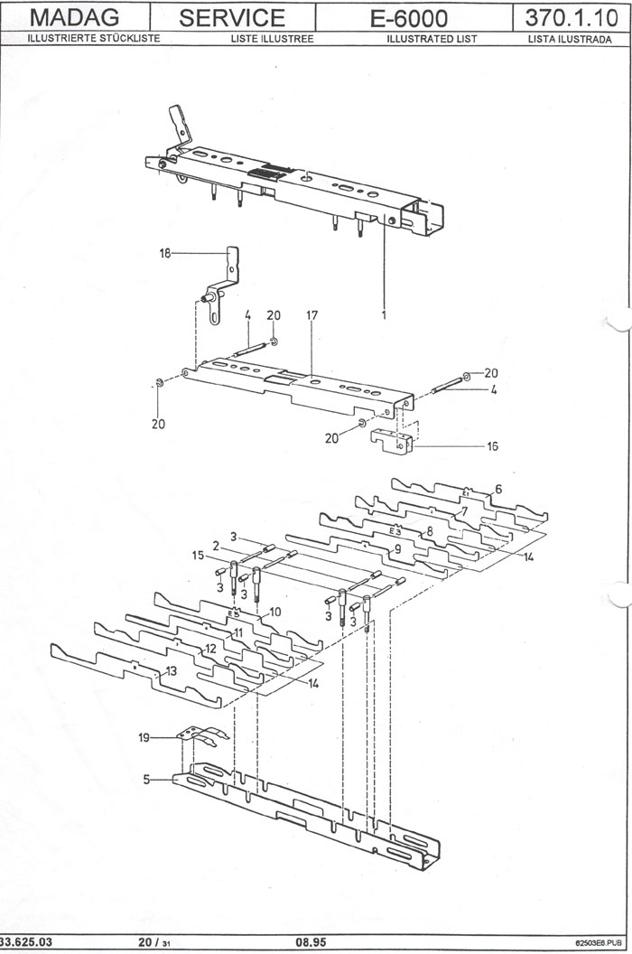
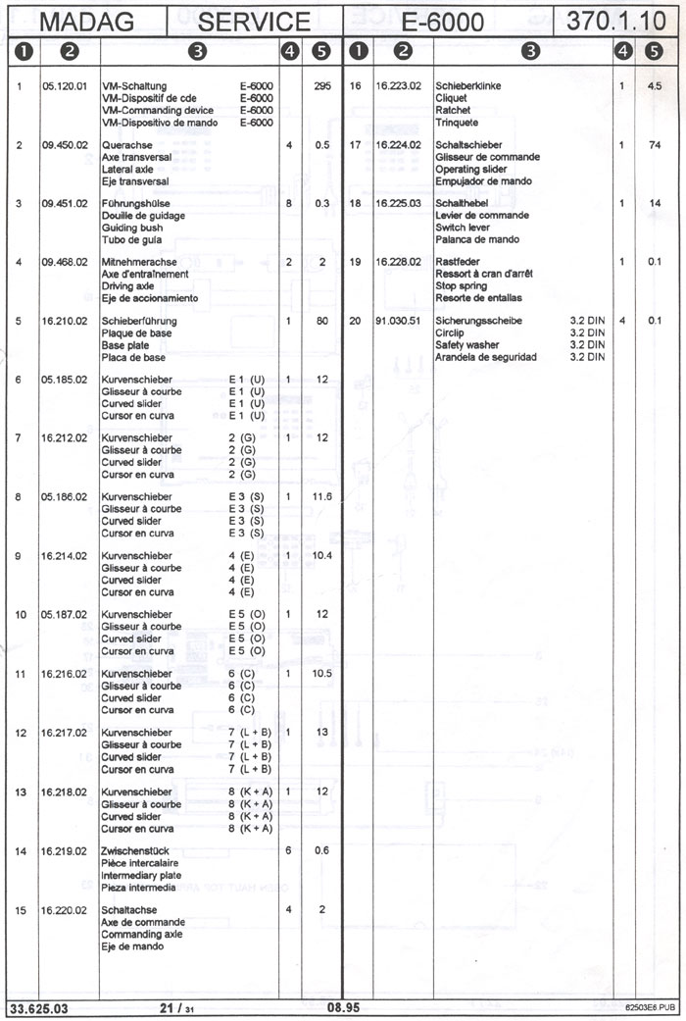
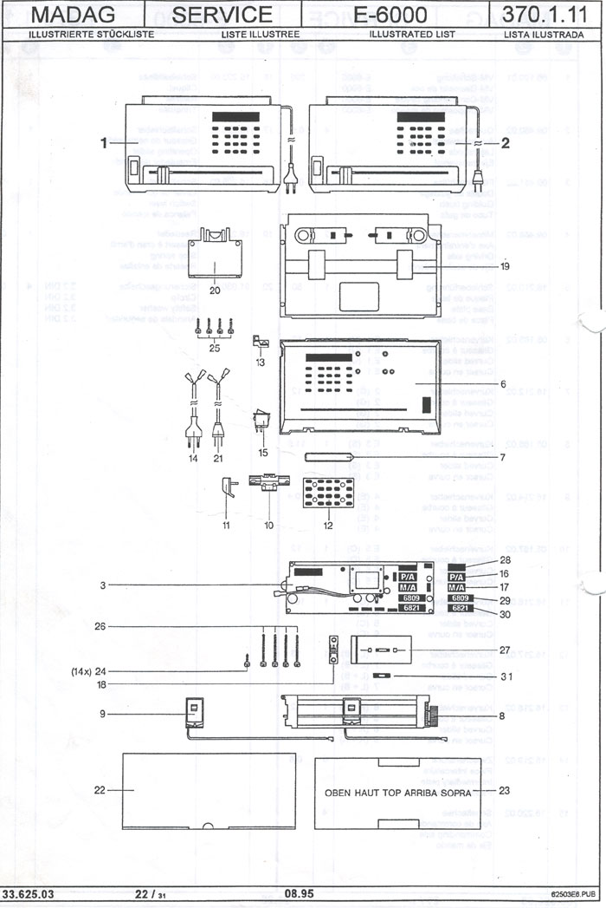
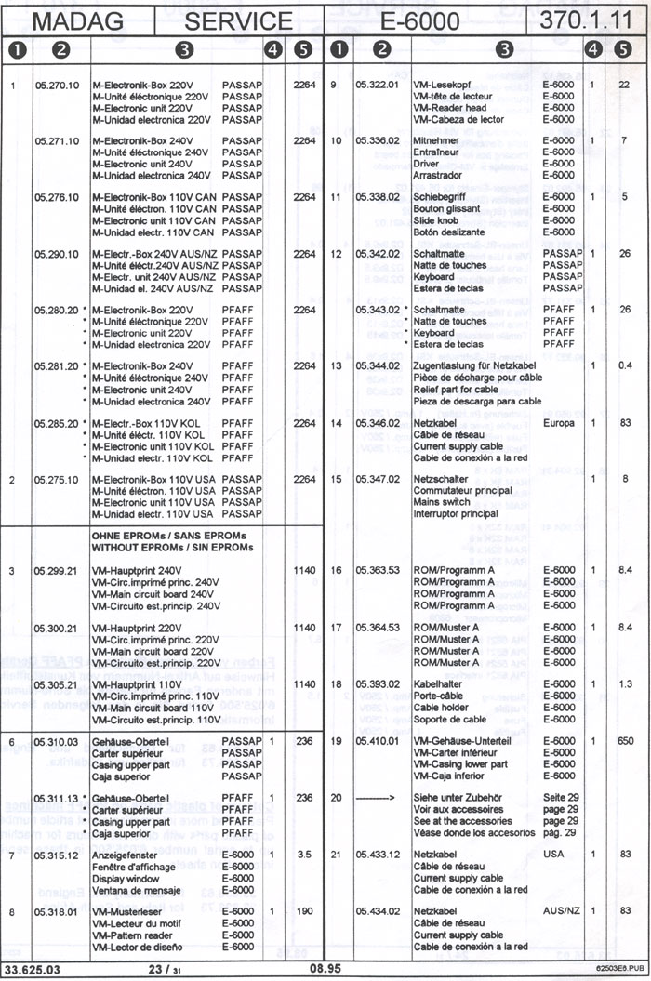
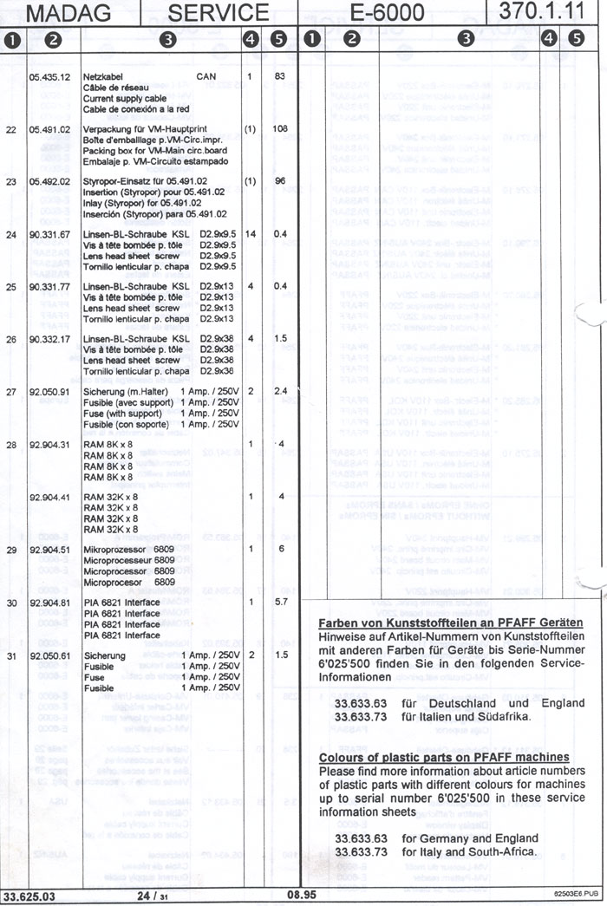
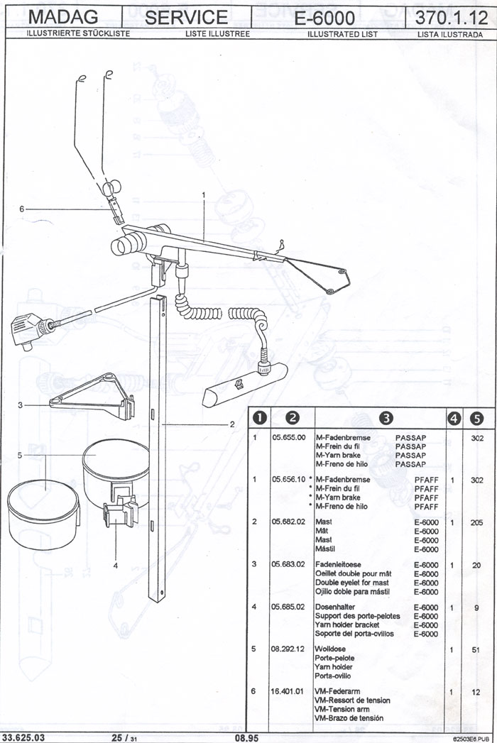
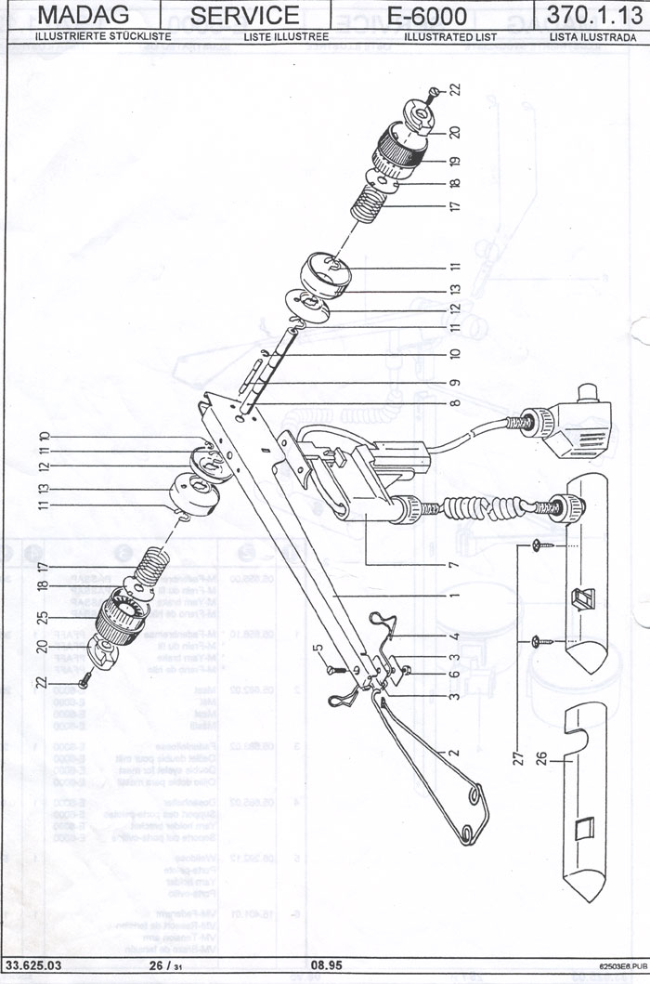
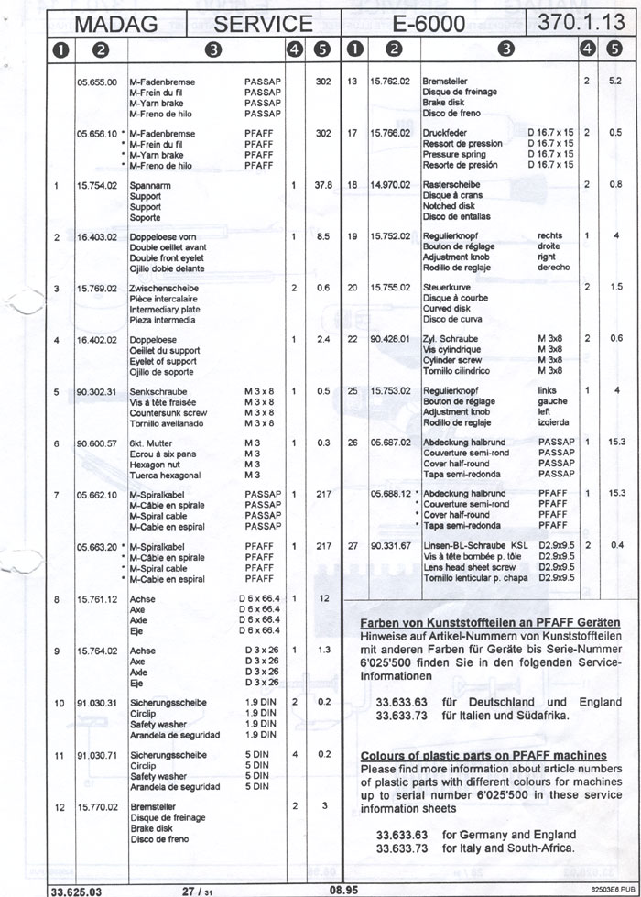
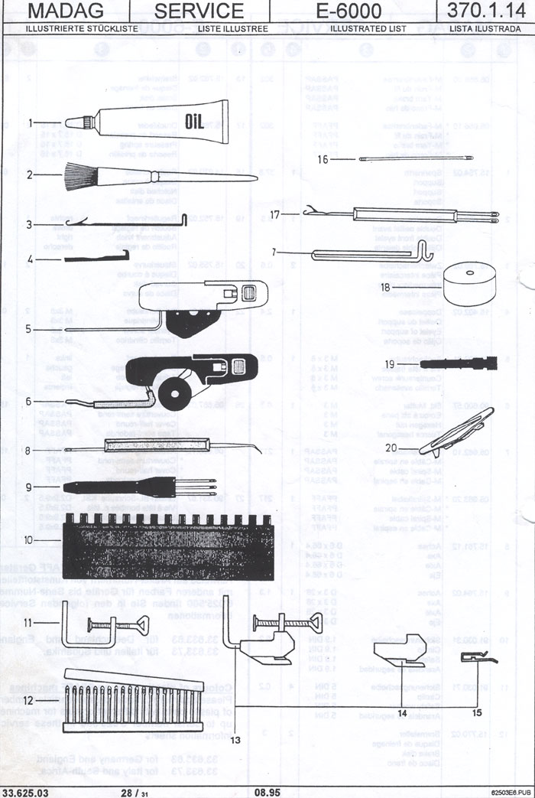
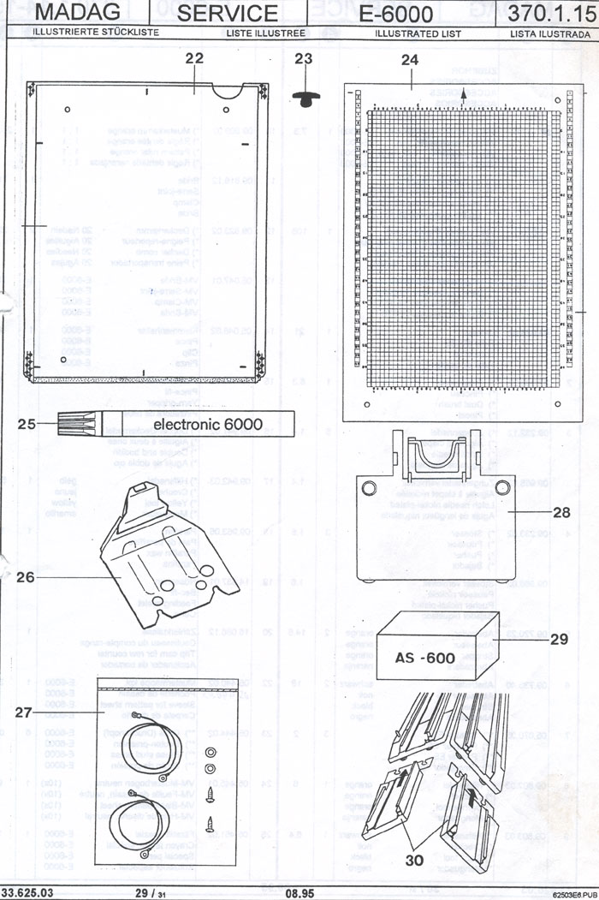
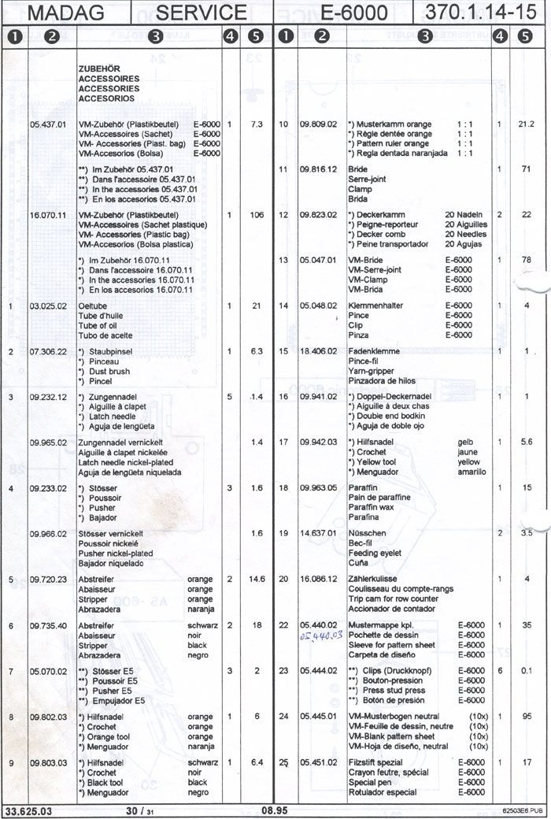

S I T E D I R E C T O R Y

SERVICE DEPARTMENT | PARTS DEPARTMENT
PASSAP E 8000 Knitting Machines | Diagrams & Numbers - E-8000  Knitting Beds & Locks
PASSAP Duomatic Knitting Machines | DIAGRAMS & NUMBERS DM-80
Top Jet Vario | PASSAP Accessories
PASSAP E 6000 Knitting Machines | DIAGRAMS & NUMBERS E-6000
U-70 Instructions (Free) | DIAGRAMS & NUMBERS 4600 Motor
U-100 Instructions (Free) | DIAGRAMS & NUMBERS - E-3000A Motor
PASSAP Vario Knitting Machines | Diagrams & Numbers - E-8000  CM-84 Color Changer
HOME | Diagrams & Numbers - E-8000  AE 812 Motor Drive
Alinea Instructions FREE  Alinea product for sale | Diagrams & Numbers - E-8000  AE 812 Fabric Take Down
USED MACHINES | PASSAP BOOKS
VISIT THESE AFFILIATED SITES
SilverReed (Studio) Knitting Machines Canada
The Sew 'n Knit 'n Serge Outlet
Peter Smith Trading Ltd.
FOR SECURE CREDIT CARD ORDERS PLEASE CALL US
TOLL-FREE FROM ANYWHERE IN NORTH AMERICA!
1-800-836-6536

